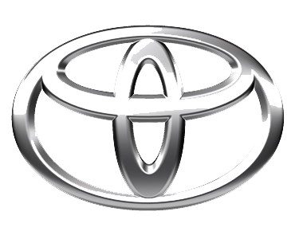
undefined
TOYOTA MOTOR CORPORATION
I. TOYOTA-CHO TOYOTA. AICHI, 471—8571(HEAD OFFICE)
or 471 8572 (Research 5 Development Group) THAILAND
TEL: +81-565-28-212

GSO Conformity Certificate CCR No. 538061
Motor Vehicles
Manufacturer: SAIC MOTOR CORPORATION LIMITED
Country of Origin: CHINA, Country of Production: CHINA
To: GCC Standardization Organization (GSO)
We hereby certify that the vehicles manufactured by SAIC MOTOR CORPORATION LIMITED
* Type: MG 5 AP31 X4 1.5L Sedan FWD 4Doors
* VlN number: LSJA36E3*S*******
* Model Year: 2025 * Produced in and after: Month 2 Year 2025
* Category: Passenger Car
Will satisfy the G50 Technical Regulations Nos: 34:20o7, 3s:2007, 36:2005, 37:2012, 38:200s, 392005, 40:2011,42:2015, 48:1984, 51:20o7, 52:2007, 53.2007, 9611988. 9721988, 9811988, 9921988,13522007, 13622007. 29021994. 4119:1994,42o:1994,421:2005,422:200s.1040:20001041:2000,1042:2000,1053:2000,1503:2010,1598:2002,1624:2002,1677:2003,1708:2o0s,1780:2010,1781:2006,1782:2008,1783:2006,1784:2o0e.Gsolso1585:2008,GSO lSO 3537:2008, GSO 150 3538:1997, G50 ECE13H:2012,GSO ECE13H-1:2012,GSO ECE13H-2:2012,GSO ECE 13H-3:2012, GSO ECE13H-4:20l2, GSO ECE13H-S:2012,GSO ECE 13H-6:2012 and the standards in the country of origin accepted by GSO in the case that no GSO technical regulations and standards are available.
All the essential technical data are as follows:
1. Weights
a. Maximum Vehicle Weight: 1650 kg b. Curb: 1210 kg
c. Maximum Axle Weight: Front: 839 kg Rear: 811 kg
2. Dimensions
a. Length: 4607 mm b. Width: 1818 mm
c. Height: 1489 mm d. Wheelbase (Fl R1) 2680 mm e. Track: Front: 1544 mm Rear: 1544 mm
3. Type of chassis and body: Monocoque
4. Number of Passengers: 5(Including the Driver)
5.Engine: Petrol a. Cylinders: 4 b. Displacement: 1495cc c. Air intake: Naturally Aspirated
d. Net Engine Power: 81 kW at 6000 rpm Pollutant Limit comply with Euro 5.
6. Transmission: Manual

7. Brakes a. Service Brakes: Hydraulic b. Emergency Brakes: Combined with the service brake
8. Fuel Economy a. Motor Vehicle Class: Passenger Car b. FE (CAFE) Combined: 16.8.7 km/L - Excellent
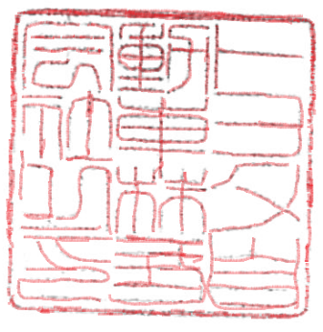
9. Any other information or local standards to be compiled: Also comply with the National regulations for member countries mentioned in the Annex of the list of Technical Regulations for MV 2025 MY-D5, when exporting to those countries. for member countries mentioned in the Annex of the list of Technical Regulations for MV 2025MY-D3, when exporting to those countries. for member countries mentioned in the Annex of the list of Technical Regulations for MV 2025 MY-D3, when exporting to those countries.
Keiko Yanagi
07 MAR 20252025
general Manager Regulation &Certiﬁcation Division

